A mad dangerous bull has freed himself from its chain. Now it's attacking all people that come by in its path. So, people of village 'Goru Mari' are frightened and at a loss. One of the villagers reported that the bull is sitting on a place (actually after all days hard work, the bull was resting). So, the villagers made a plan to imprison the cow with a fence.
Assume the village as a 2D grid, where the bull is sitting on coordinate (x, y). And some pairs of coordinates will be given (x₁, y₁), (x₂, y₂), that means the villagers can put bamboos between this two points. Actually there is a tree in (x₁, y₁) and also one in (x₂, y₂), and there are branches in the trees such that the villagers can tie two bamboos so that the bull won't be able to cross. The villagers are not able to place bamboos between trees which are not listed (may be, there are no suitable branches in those trees such that a bamboo can be tied).
Now the villagers want to imprison the bull, that means they want to use some bamboos to cover an area such that the bull will be inside that area and not able to cross that area. The villagers want the area to be convex. That means each angle is less than or equal to 180 degree. If there is a bamboo position that crosses any other bamboo position, then only one of them can be used.
Since bamboos are not so cheap, so the villagers want to imprison the bull such that the total length of the bamboo is as small as possible. And villagers are not good at math, so they asked your help.
Input
Input starts with an integer T (≤ 125), denoting the number of test cases.
Each case starts with a blank line. The next line contains three integers n x y where n (1 ≤ n ≤ 100) denotes the number of tree pairs, (x, y) means the position of the bull. Each of the next n lines contains four integers x₁ y₁ x₂ y₂, meaning that you can place bamboos between (x₁, y₁) and (x₂, y₂). You can assume that all the co-ordinates given for this problem satisfy (-10⁴ ≤ x_{i}, y_{i} ≤ 10⁴) and no two trees and the position of the bull will be collinear.
Output
For each case, print the case number and the minimum length of the bamboos needed. If no such solution is found, print -1. Errors less than 10⁻⁶ will be ignored.
Sample Input
2

3 2 1
0 0 10 0
10 0 0 10
0 10 0 0

1 5 5
0 0 10 0
Sample Output
Case 1: 68.2842712475
Case 2: -1.000

学习了一波叉乘知识。。
note：用到叉乘的知识，两个向量的叉乘得到一个垂直于这两个向量的向量，如果这两个向量不共线的话。否则，得到的是0。结果向量的方向可以用右手定则判断。
如图所示，线段AB和点P
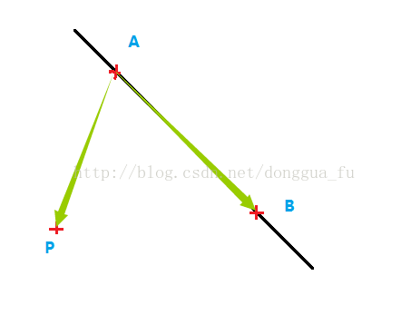
印象里，只学过三维向量的叉乘，将向量AB和AP扩展到三维，得到
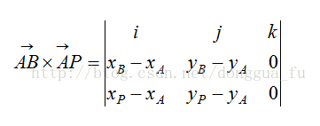
跟预计的是相符合的，是一个平行于Z轴的向量，即
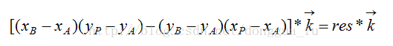
如果 res<0，说明结果向量垂直于屏幕向里，也就是指向Z轴的负方向，P点在直线的下侧。
如果res>0，说明结果向量垂直于屏幕向外，也就是指向Z轴的正方向，P点在直线的上侧。
如果res=0，P点在直线上。
然后就是把所有线段弄成同一个方向

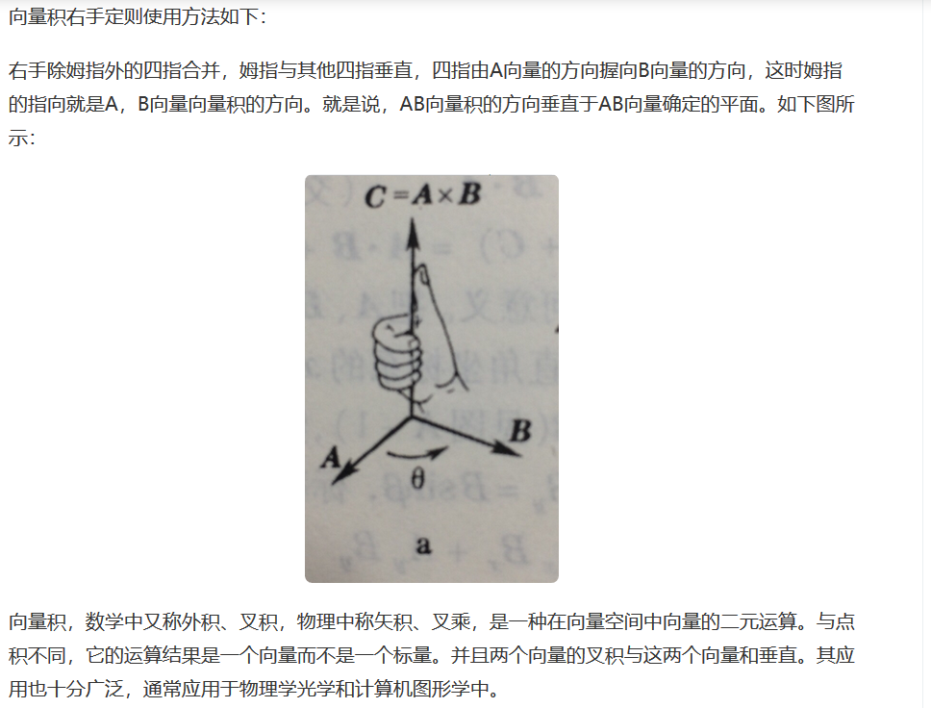

#include<iostream>
#include<cstdio>
#include<cstring>
#include<algorithm>
#include<map>
#include<queue>
#include<vector>
#include<cmath>
#define ll long long
using namespace std;
typedef pair<int,int> Point;
struct node
{
Point start,to;
double dis;
}e[200];
int n;
map<Point,vector<int> >G;
int chacheng(Point a,Point b,Point c)
{
return (c.first-a.first)*(b.second-a.second)-(c.second-a.second)*(b.first-a.first)<=0;
}
double cal(Point a,Point b)
{
return sqrt((b.first-a.first)*(b.first-a.first)+(b.second-a.second)*(b.second-a.second));
}
double dp[200][200];
int main()
{
int t; int kk=0;
scanf("%d",&t);
while(t--)
{
kk++;
G.clear();
Point N;
scanf("%d %d %d",&n,&N.first,&N.second);
for(int i=0;i<n;i++)
{
scanf("%d%d%d%d",&e[i].start.first,&e[i].start.second,&e[i].to.first,&e[i].to.second);
if(!chacheng(e[i].start,e[i].to,N)) swap(e[i].start,e[i].to);
e[i].dis=cal(e[i].start,e[i].to);
G[e[i].start].push_back(i);
}
for(int i=0;i<190;i++)
{
for(int j=0;j<190;j++)
{
dp[i][j]=0x3fffffff;
}
}
for(int i=0;i<n;i++)
{
for(int j=0;j<G[e[i].to].size();j++)
{
int tohao=G[e[i].to][j];
if(chacheng(e[i].start,e[i].to,e[tohao].to))
{
dp[i][tohao]=e[i].dis+e[tohao].dis;
}
}
}
for(int k=0;k<n;k++)
{
for(int i=0;i<n;i++)
{
for(int j=0;j<n;j++)
{
dp[i][j]=min(dp[i][k]+dp[k][j],dp[i][j]);
}
}
}
double ans=0x3fffffff;
for(int i=0;i<n;i++) ans=min(ans,dp[i][i]);
printf("Case %d: ",kk);
if(fabs(ans-0x3fffffff)<1e-9)
{
printf("-1.000\n");
}
else
{
printf("%lf\n",ans);
}
}
return 0;
}

